How to import Pax8 Bookmarks into Microsoft Edge

Step 1 - Download <https://github.com/benopax8apac/MAICPP/blob/main/Pax8%20Microsoft%20AI%20Cloud%20Partner%20Program%20Bookmarks.html>

Step 2 – Import Bookmarks into Edge

Press Ctrl + Shift + O (not zero)

Click More Option 3 dots

Click Import Favourites

Click “Choose what to import”

Choose Favourites or bookmarks HTML File

Choose File

Import the file you just downloaded from Step 1

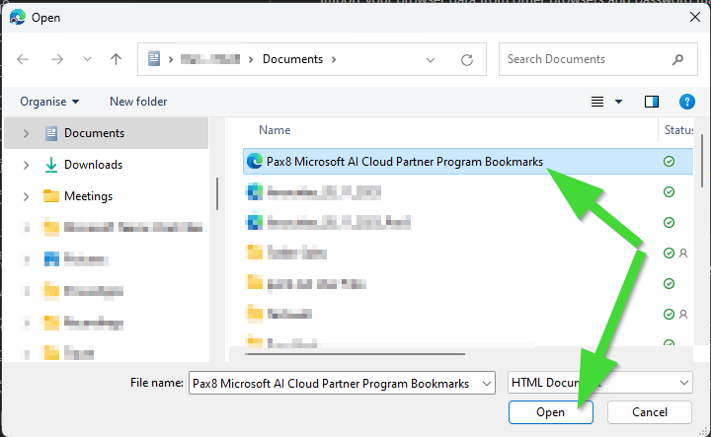

Press Ctrl + Shift + B to see your bookmarks

Check the Others Favourites Folder

